#include <iostream>

#include <string>

using namespace std;

const int MAX_ITEMS = 100;

//! Base class

class LibraryItem

{

private:

string title;

string author;

int year;

public:

LibraryItem(string title, string author, int year)

{

this->title = title;

this->author = author;

this->year = year;

}

string getTitle()

{

return title;

}

string getAuthor()

{

return author;

}

void display()

{

cout << "Title: " << title << endl;

cout << "Author: " << author << endl;

cout << "Year of Publication: " << year << endl;

}

};

//* Derived class Book

class Book : public LibraryItem

{

private:

int pages;

public:

Book(string title, string author, int year, int pages) : LibraryItem(title, author, year)

{

this->pages = pages;

}

void display()

{

LibraryItem::display();

cout << "Number of Pages: " << pages << endl;

}

};

//* Derived class magazines

class Magazine : public LibraryItem

{

private:

int issueNumber;

public:

Magazine(string title, string author, int year, int issueNumber) : LibraryItem(title, author, year)

{

this->issueNumber = issueNumber;

}

void display()

{

LibraryItem::display();

cout << "Issue Number: " << issueNumber << endl;

}

};

//* Library class to manage items

class Library

{

private:

LibraryItem *collection[MAX_ITEMS];

int itemCount;

public:

Library()

{

itemCount = 0;

}

void addItem(LibraryItem *item)

{

if (itemCount < MAX_ITEMS)

{

collection[itemCount++] = item;

}

else

{

cout << "Cannot add more items, Library is at maximum capacity." << endl;

}

}

void displayItems()

{

for (int i = 0; i < itemCount; ++i)

{

collection[i]->display();

cout << "--------------------------\n";

}

}

};

//! Base class

class Person

{

protected:

string name;

public:

Person(string name)

{

this->name = name;

}

string getName()

{

return name;

}

};

class Staff : public Person

{

public:

Staff(string name) : Person(name) {}

void addItemToLibrary(LibraryItem *item, Library &library)

{

library.addItem(item);

cout << getName() << " added an item to the library." << endl;

}

void displayLibraryCollection(Library &library)

{

cout << getName() << " is displaying the library's collection:" << endl;

library.displayItems();

}

};

class Patron : public Person

{

public:

Patron(string name) : Person(name) {}

void exploreLibraryCollection(Library &library)

{

cout << getName() << " is exploring the library's collection:" << endl;

library.displayItems();

}

};

int main()

{

cout << "=====================================================\n";

cout << "========= Welcome to the library's collection =======\n";

cout << "=====================================================\n";

//! DATA

Library library;

Staff staff("Library Staff");

cout << "\n####### Books #######\n"

<< endl;

Book book1("The Catcher in the Rye", "J.D. Salinger", 1951, 224);

staff.addItemToLibrary(&book1, library);

Book book2("To Kill a Mockingbird", "Harper Lee", 1960, 281);

staff.addItemToLibrary(&book2, library);

Book book3("The Great Gatsby", "F. Scott Fitzgerald", 1925, 180);

staff.addItemToLibrary(&book3, library);

staff.displayLibraryCollection(library);

cout << "\n####### Magazines #######\n"

<< endl;

Magazine magazine1("National Geographic", "Susan Goldberg", 2023, 150);

staff.addItemToLibrary(&magazine1, library);

Magazine magazine2("The New Yorker", "David Remnick", 2023, 80);

staff.addItemToLibrary(&magazine2, library);

staff.displayLibraryCollection(library);

cout << "\n--------------------------\n";

Patron patron("Library Patron 1");

patron.exploreLibraryCollection(library);

return 0;

}

output ✔️

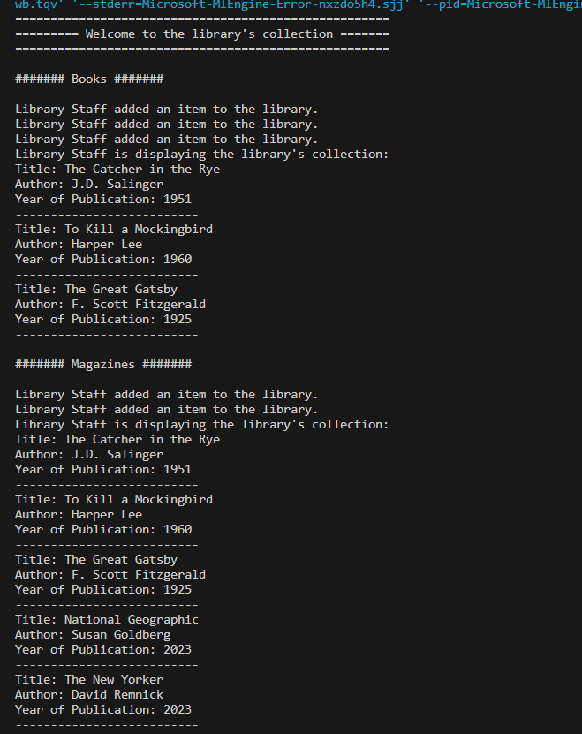

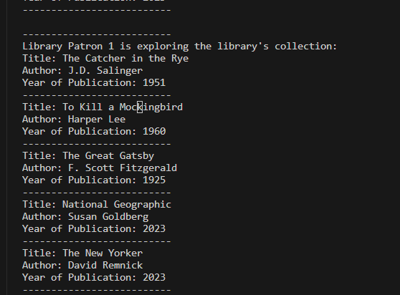

output ✔️

=====================================================

========= Welcome to the library's collection =======

=====================================================

####### Books #######

Library Staff added an item to the library.

Library Staff added an item to the library.

Library Staff added an item to the library.

Library Staff is displaying the library's collection:

Title: The Catcher in the Rye

Author: J.D. Salinger

Year of Publication: 1951

--------------------------

Title: To Kill a Mockingbird

Author: Harper Lee

Year of Publication: 1960

--------------------------

Title: The Great Gatsby

Author: F. Scott Fitzgerald

Year of Publication: 1925

--------------------------

####### Magazines #######

Library Staff added an item to the library.

Library Staff added an item to the library.

Library Staff is displaying the library's collection:

Title: The Catcher in the Rye

Author: J.D. Salinger

Year of Publication: 1951

--------------------------

Title: To Kill a Mockingbird

Author: Harper Lee

Year of Publication: 1960

--------------------------

Title: The Great Gatsby

Author: F. Scott Fitzgerald

Year of Publication: 1925

--------------------------

Title: National Geographic

Author: Susan Goldberg

Year of Publication: 2023

--------------------------

Title: The New Yorker

Author: David Remnick

Year of Publication: 2023

--------------------------

--------------------------

Library Patron 1 is exploring the library's collection:

Title: The Catcher in the Rye

Author: J.D. Salinger

Year of Publication: 1951

--------------------------

Title: To Kill a Mockingbird

Author: Harper Lee

Year of Publication: 1960

--------------------------

Title: The Great Gatsby

Author: F. Scott Fitzgerald

Year of Publication: 1925

--------------------------

Title: National Geographic

Author: Susan Goldberg

Year of Publication: 2023

--------------------------

Title: The New Yorker

Author: David Remnick

Year of Publication: 2023

--------------------------

class digrame

